DSA

UNIT 3

1. **Write an algorithm for depth first traversal of a graph**

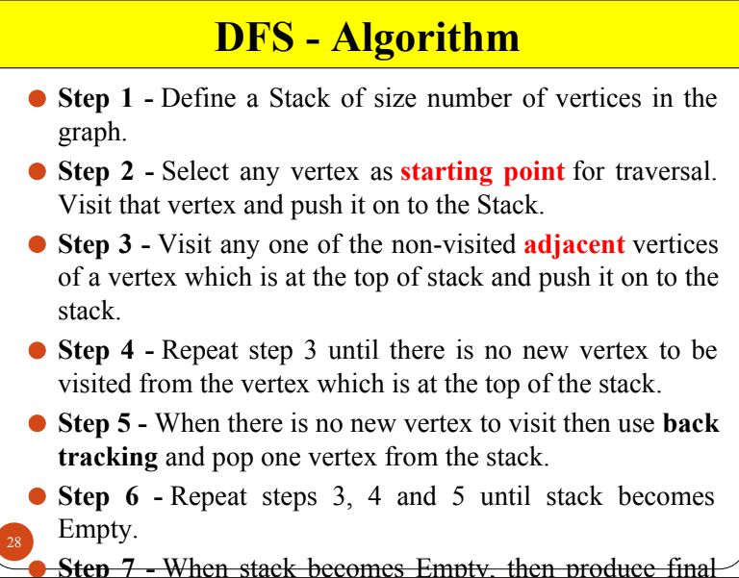

1. **Construct the minimum spanning tree (MST) for the given graph using Prim’s Algorithm staring from vertex 6.**

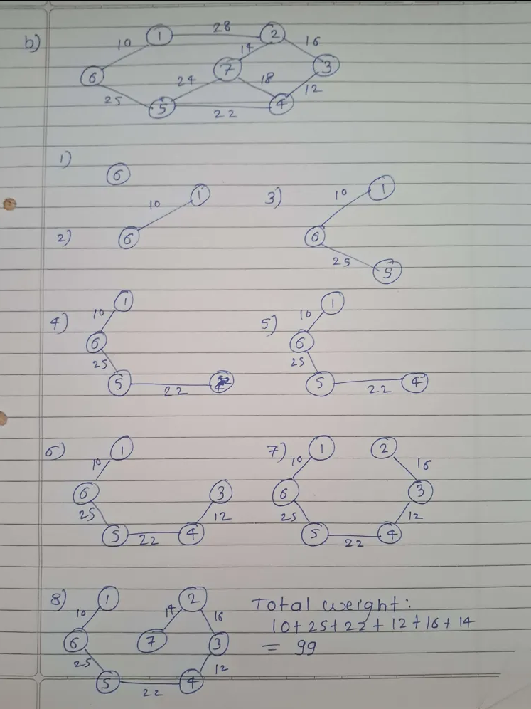

1. **What is topological sorting? Find topological sorting of given graph.**

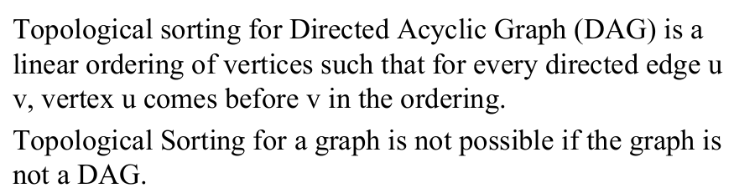

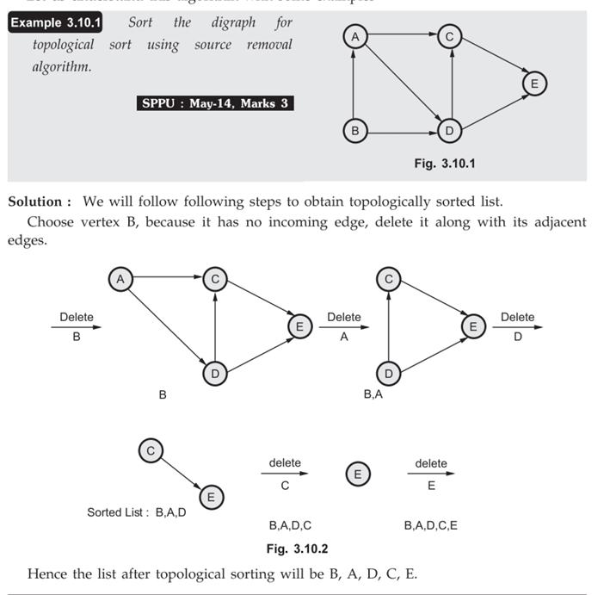

1. **Write an algorithm for breadth first traversal of a graph.**

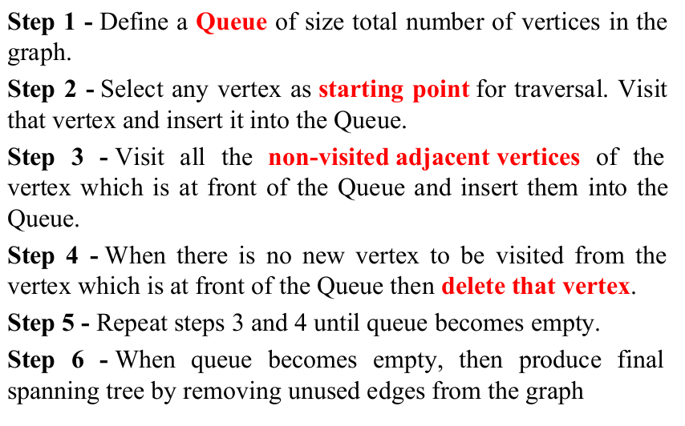

1. **Using Prim’s Algorithm, find the cost of minimum spanning tree (MST) of the given graph starting from vertex ‘a’**

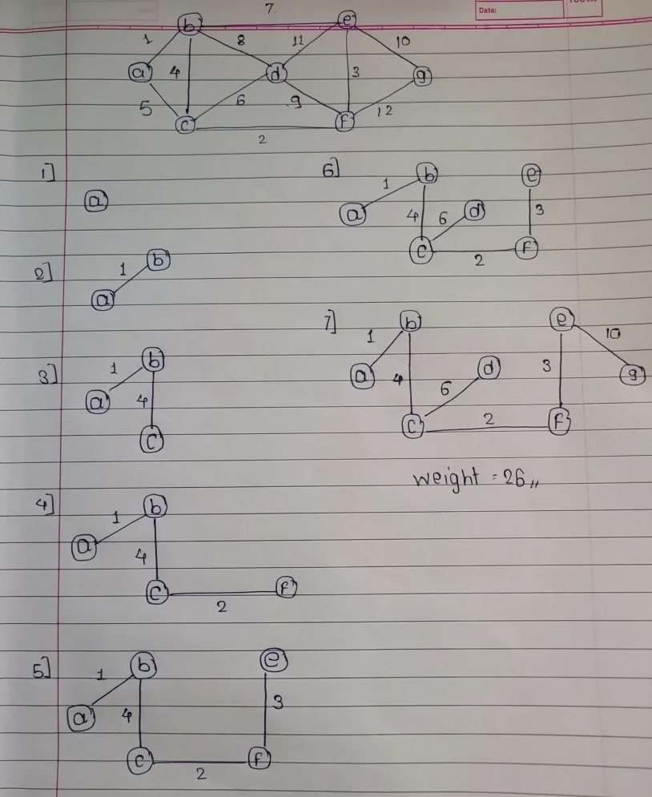

1. 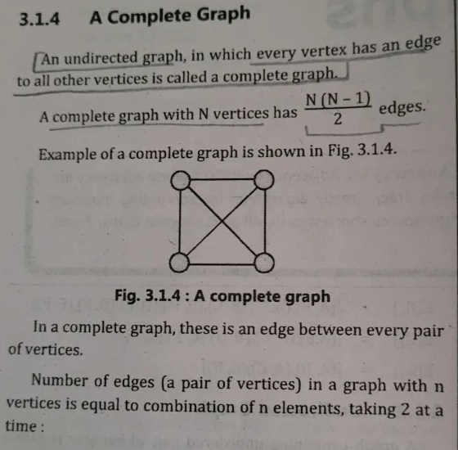**Define the following terms : i) Complete Graph ii) Connected Graph iii) Subgraph**

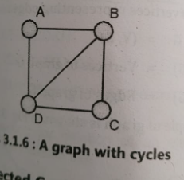

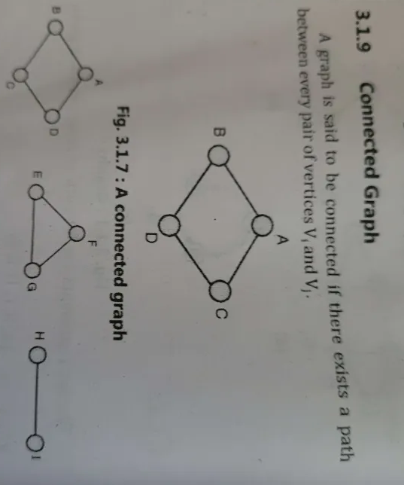

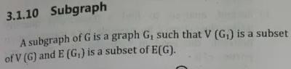

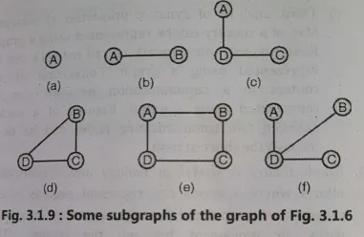

1. **Write Floyd Warshall Algorithm**

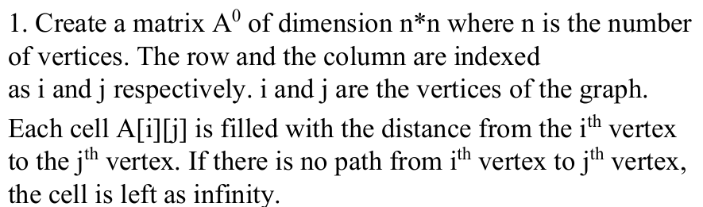

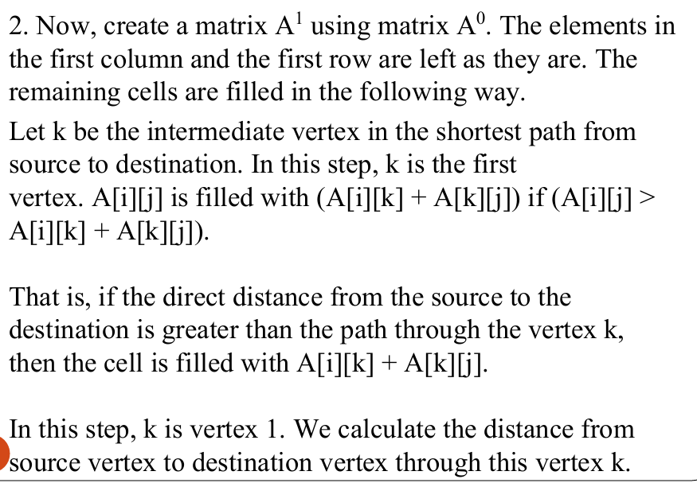

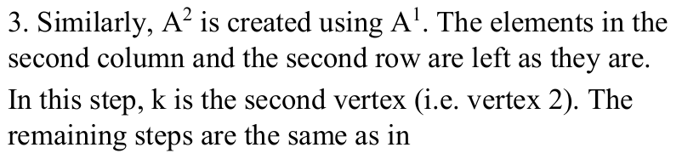

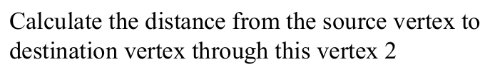

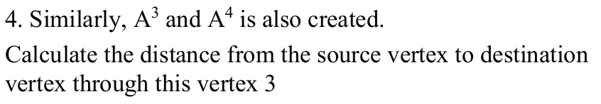



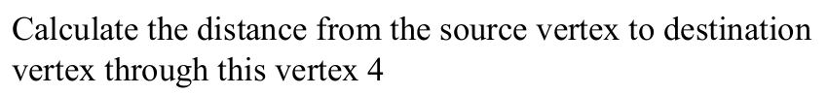

1. **Apply Dijkstra’s Algorithm for the graph given below, and find the shortest path from node A to node C.**

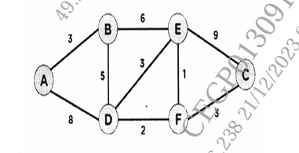

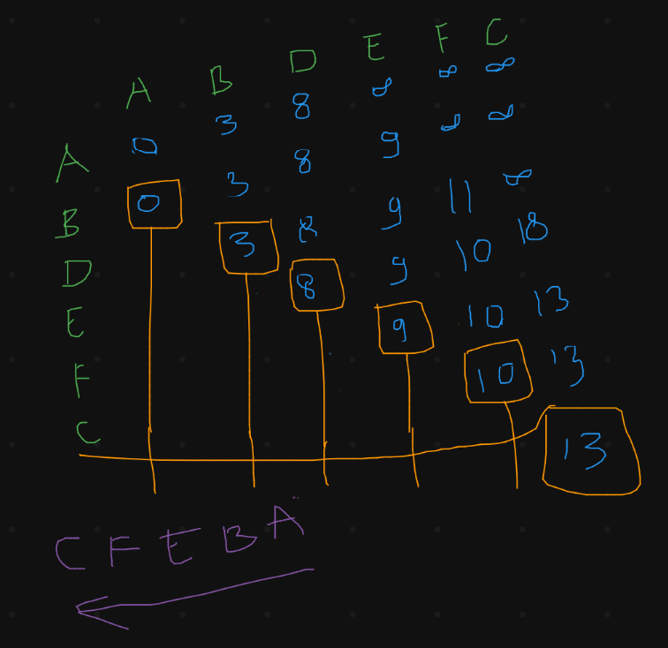

1. **Define indegree & outdegree of a directed graph. Write degree for G1 & G2. Write indegree & outdegree of each vertex for G3 graph.**

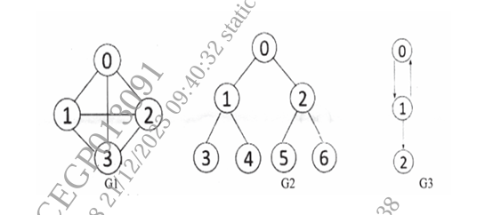

1. **Construct the minimum spanning tree (MST) for the given graph using Kruskal’s Algorithm.**

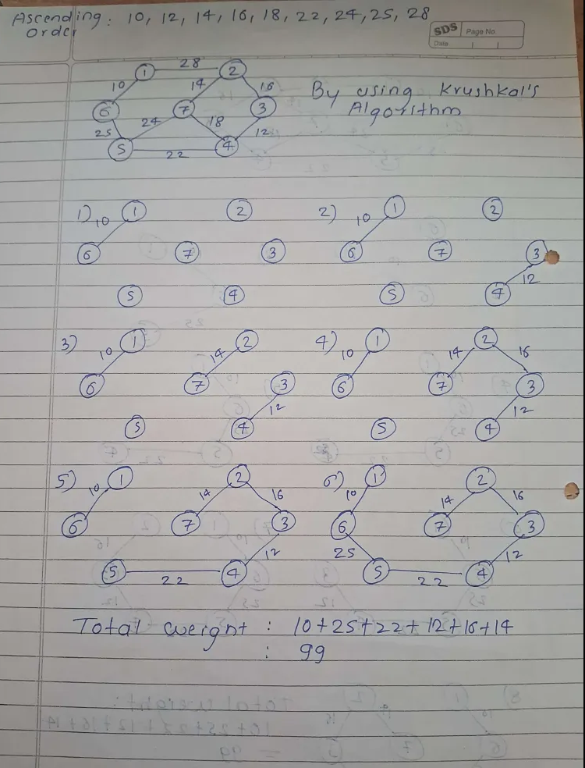

1. **Find the number of different topological orderings possible for the given graph**

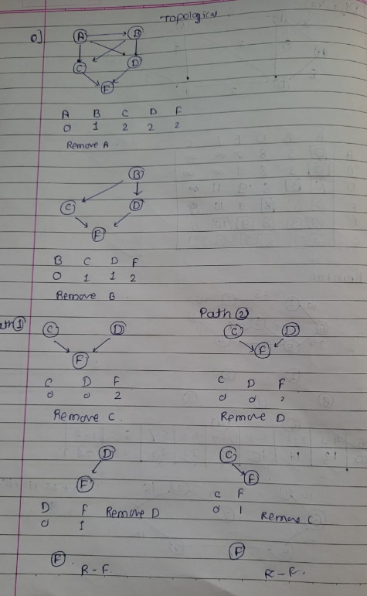

1. **Elaborate following terminologies : i) Graph ii) Adjacency List iii) Adjacency Matrix**

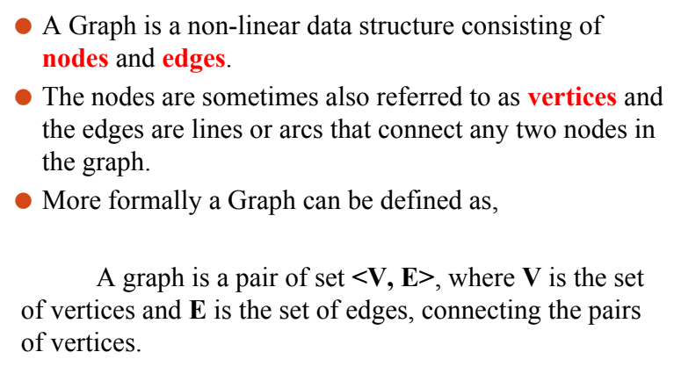

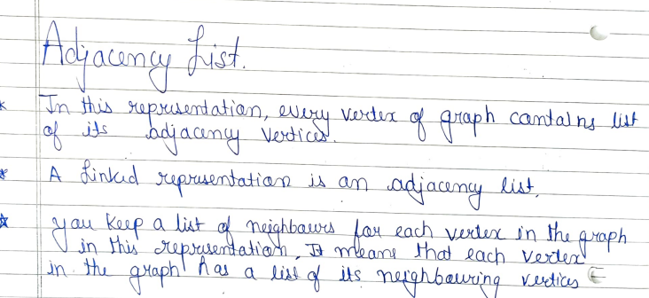

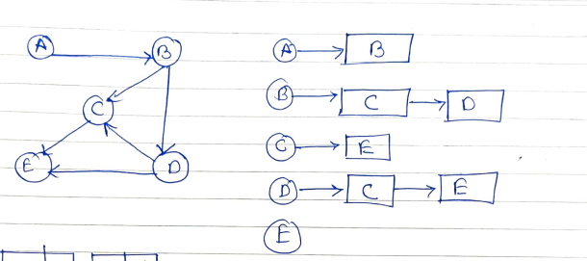

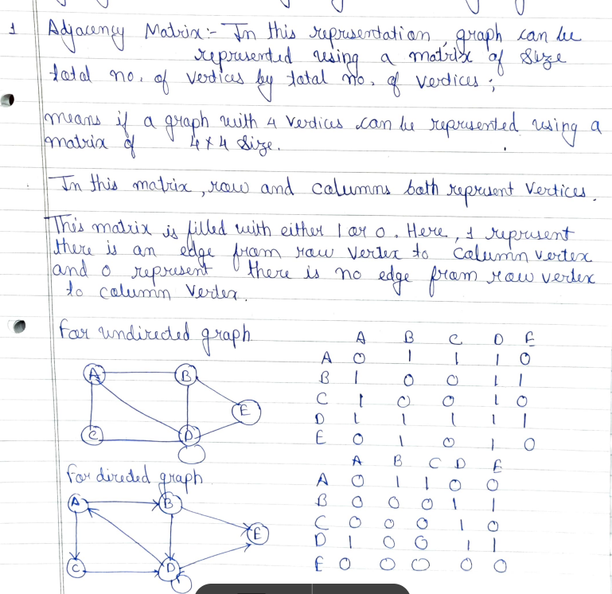

1. **Differentiate between tree and graph**

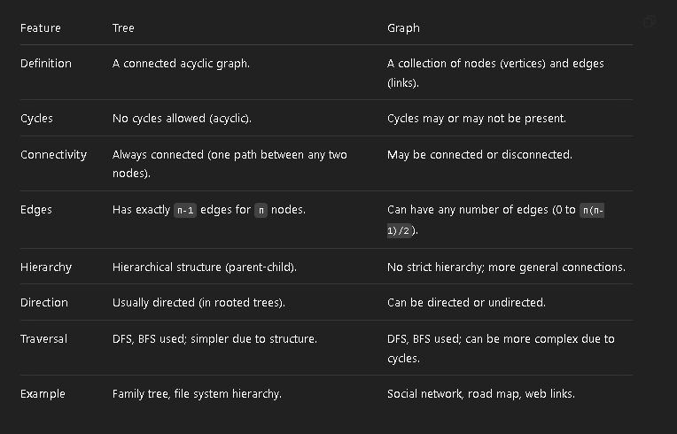

1. **Write pseudo code for Floyd-Warshall algorithm.**

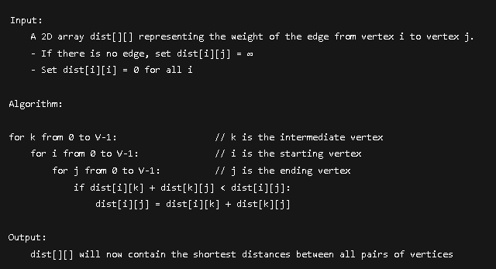

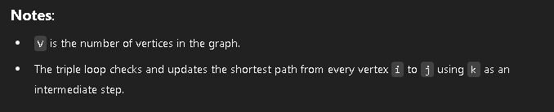

1. **Write Prim’s algorithm to find minimum spanning tree**

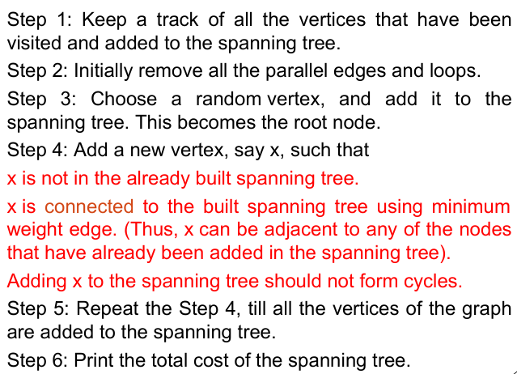

1. **Write the applications of : i) Graph ii) BFS iii) DFS**

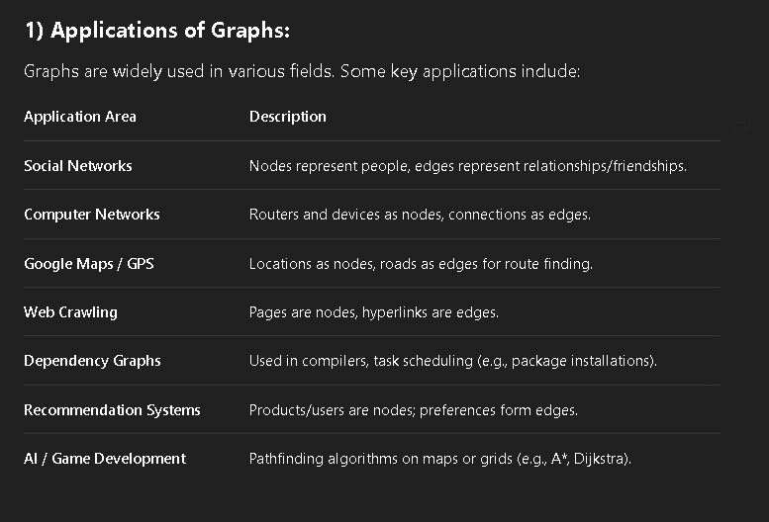

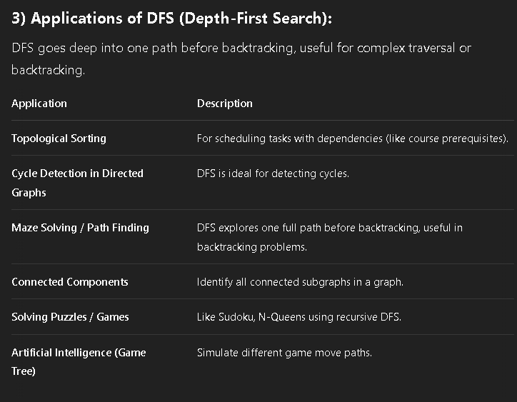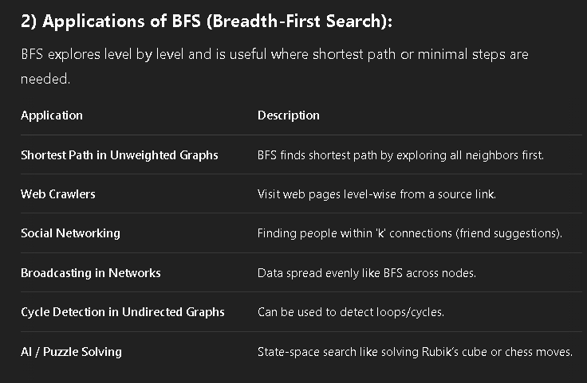

DSA

UNIT 4

1. **Construct an AVL Tree by inserting numbers from 1 to 8**

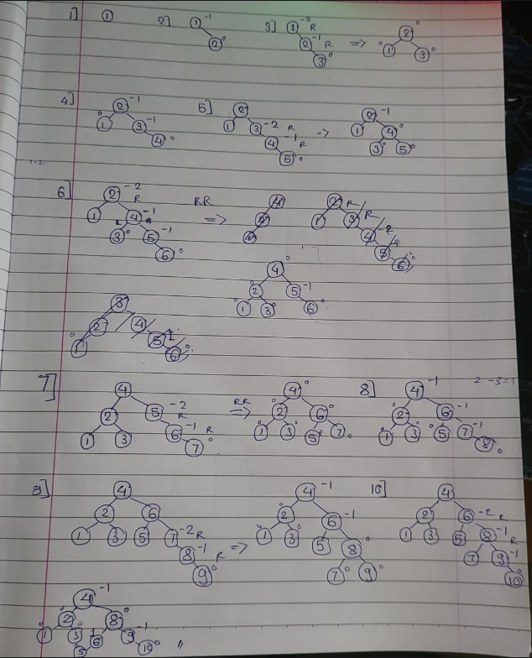

1. **Define Red Black tree. List its properties. Give example of it.**

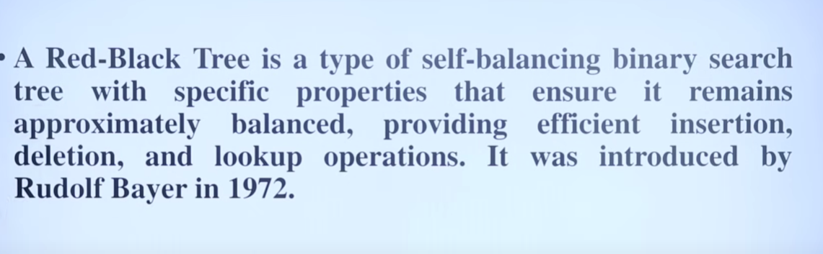

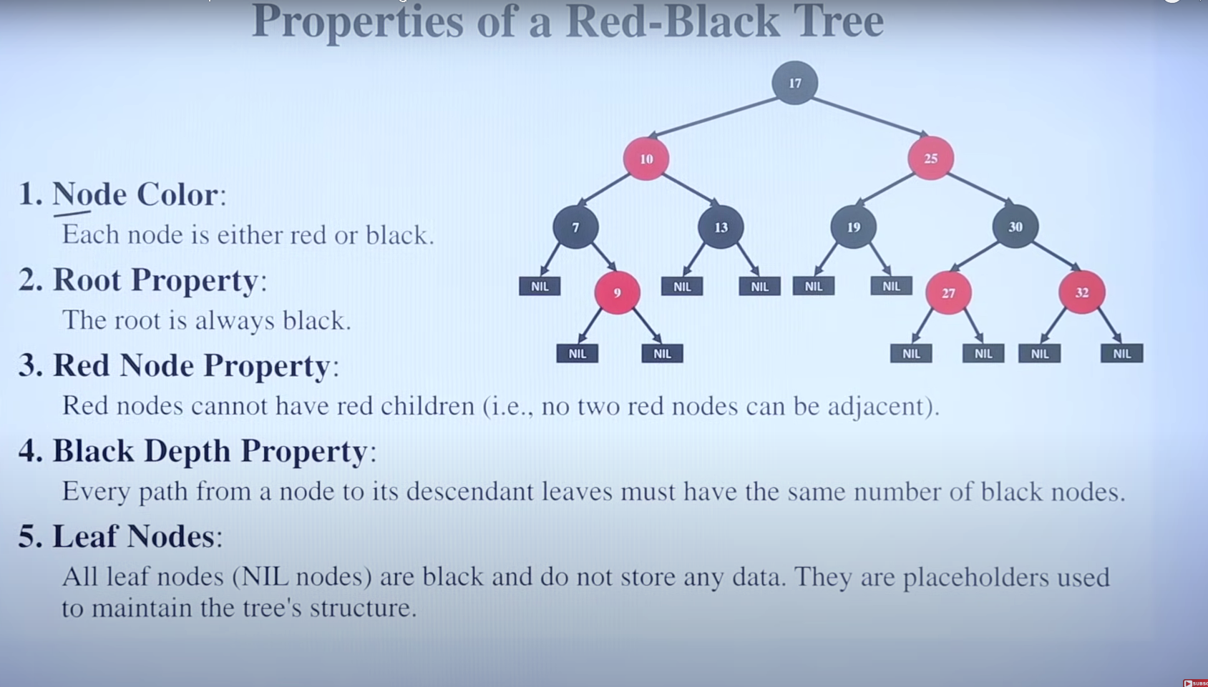

1. **Write functions for RR and RL rotation with respect to AVL tree.**

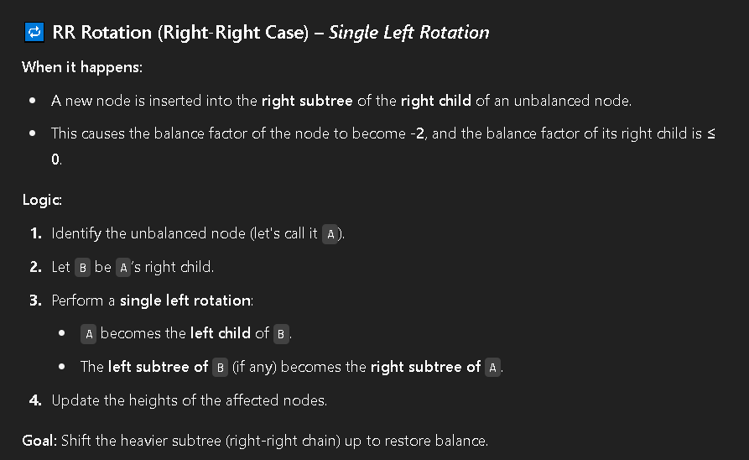 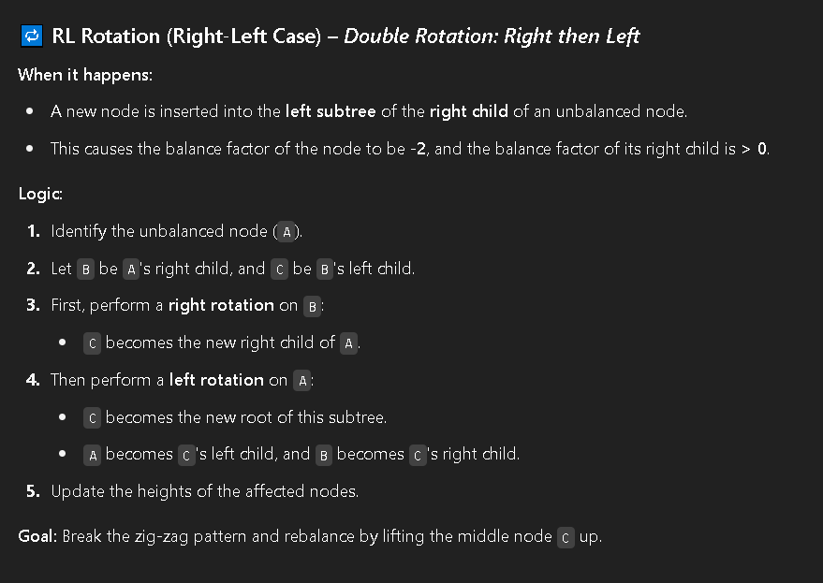

1. **Construct an AVL Tree for following data : 50, 25, 10, 5, 7, 3, 30, 20, 8, 15**

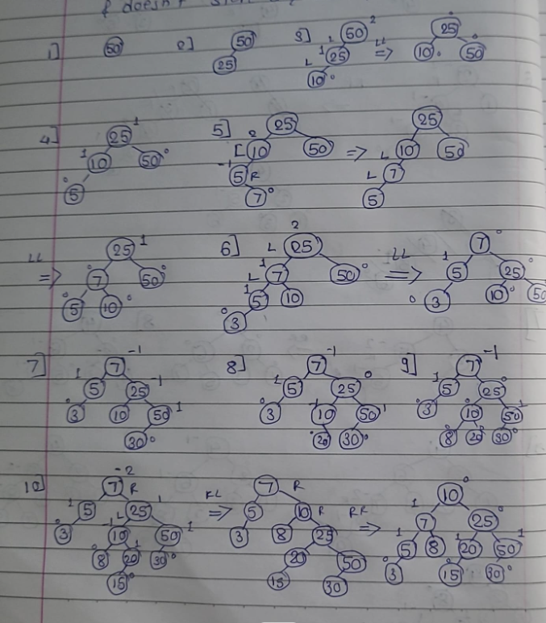

1. **Explain with example K dimensional tree.**

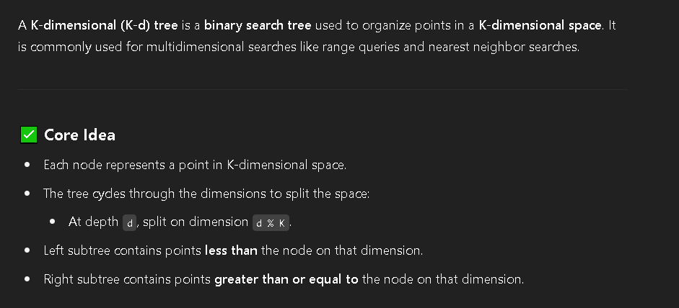

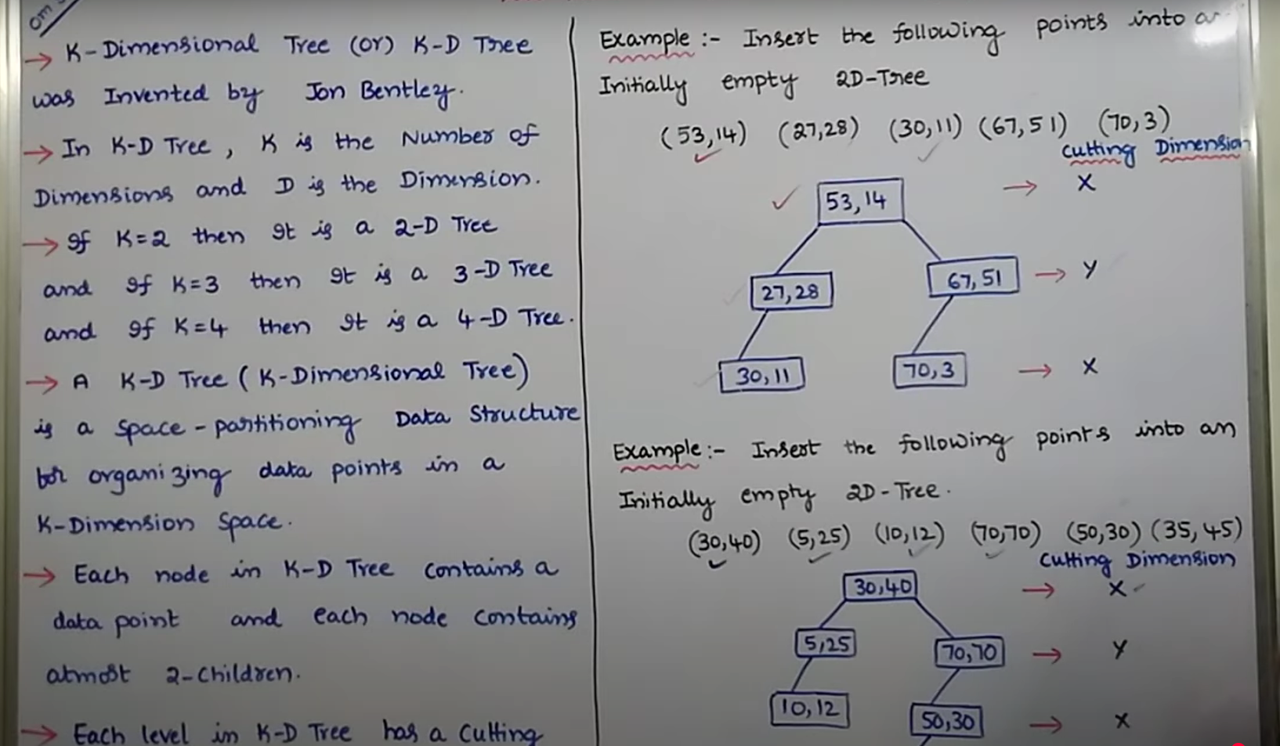

1. **Explain static and dynamic tree tables with suitable example.**

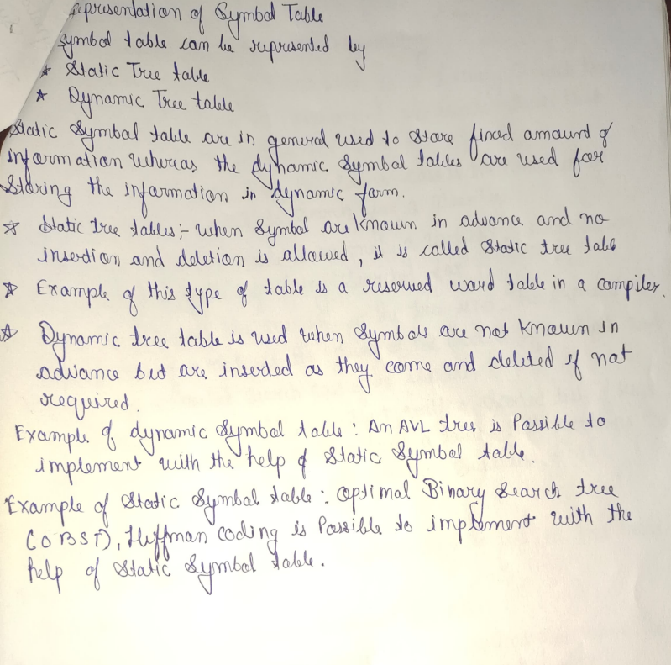

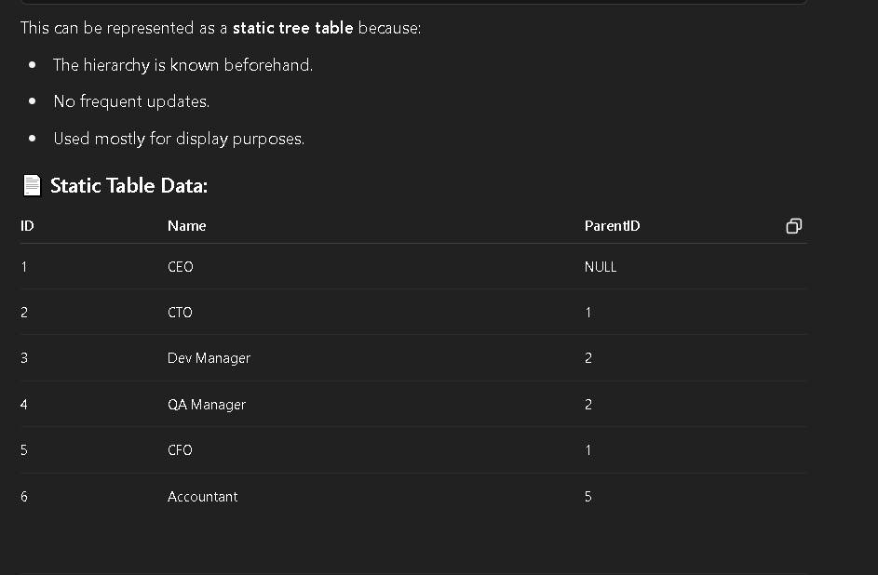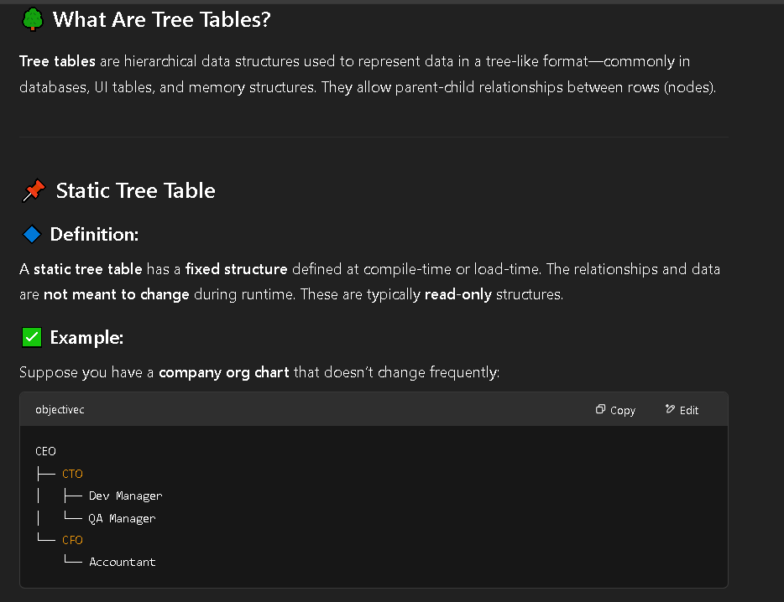

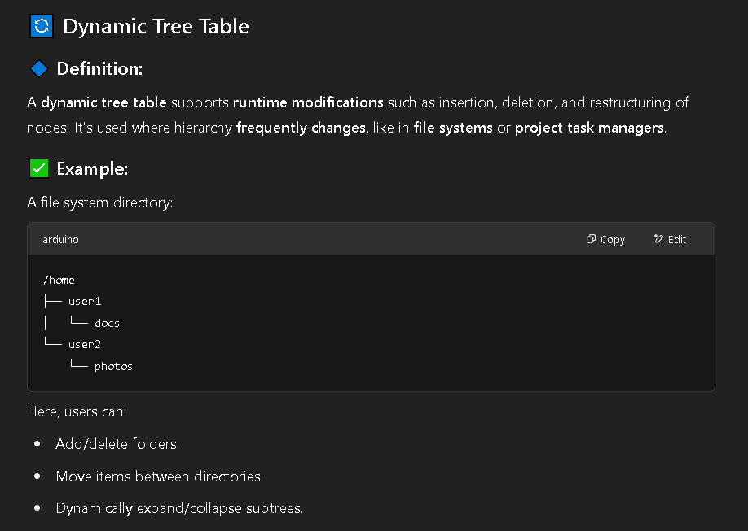

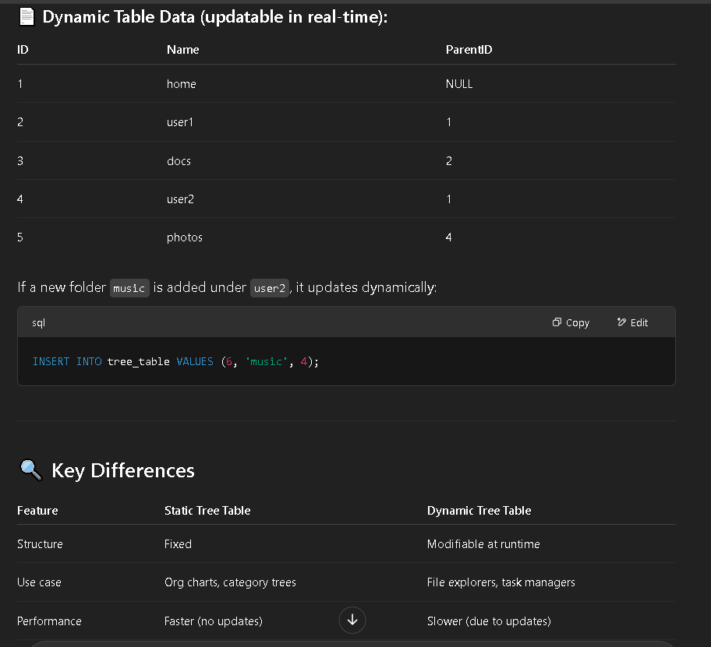

1. **Construct AVL tree for insertion of following data 9, 15, 20, 8, 7, 13, 10.**

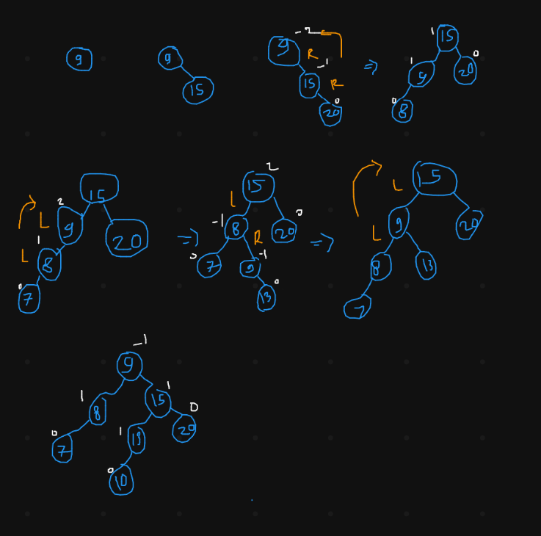

1. **Draw splay tree after**

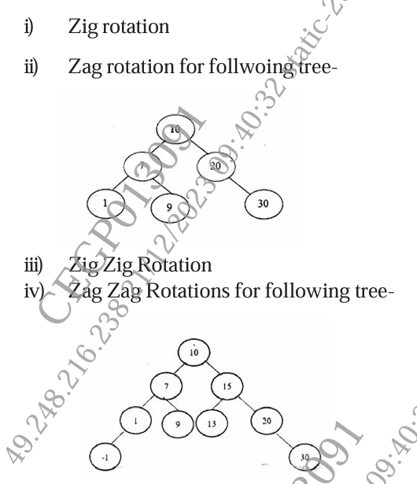

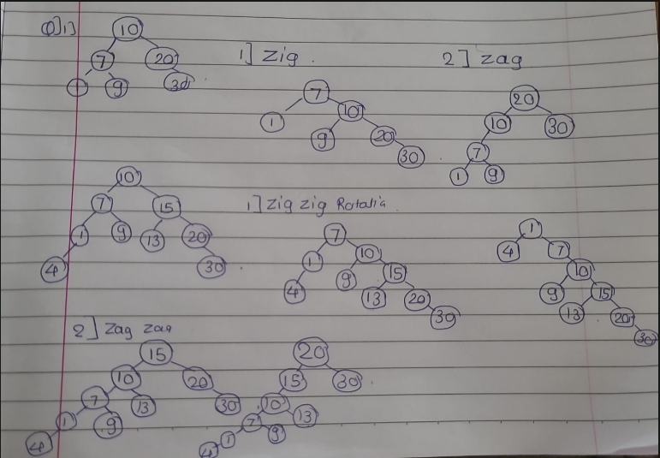

1. **Create 2D tree for following data: (3, 6), (17, 15), (13, 15), (6, 12), (9, 1) (2,7), (10, 19). Also plot all the points in XY plane.**

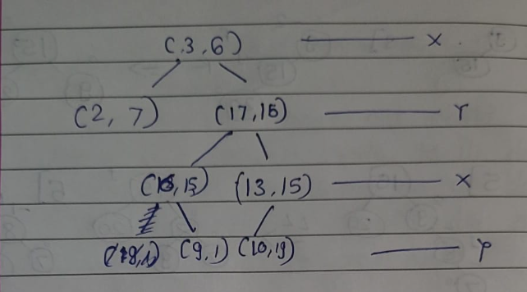

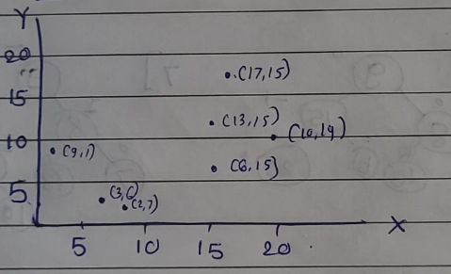

**X**

**Y**

1. **Construct AVL tree for insertion of following data: 63, 9, 19, 27, 18, 108, 99, 81**

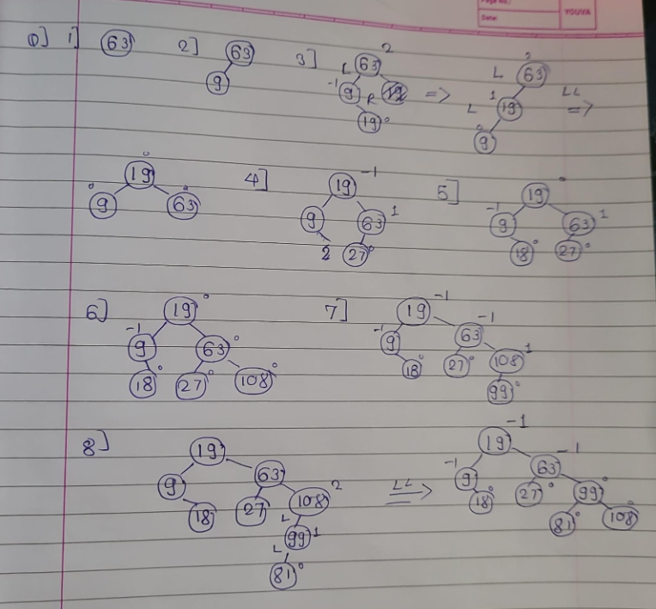

1. **Write the functions for split & skew operations in AA tree.**

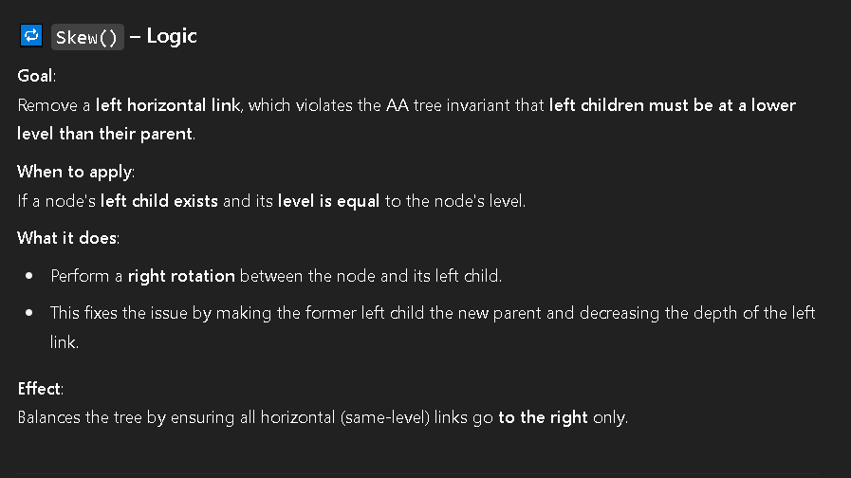

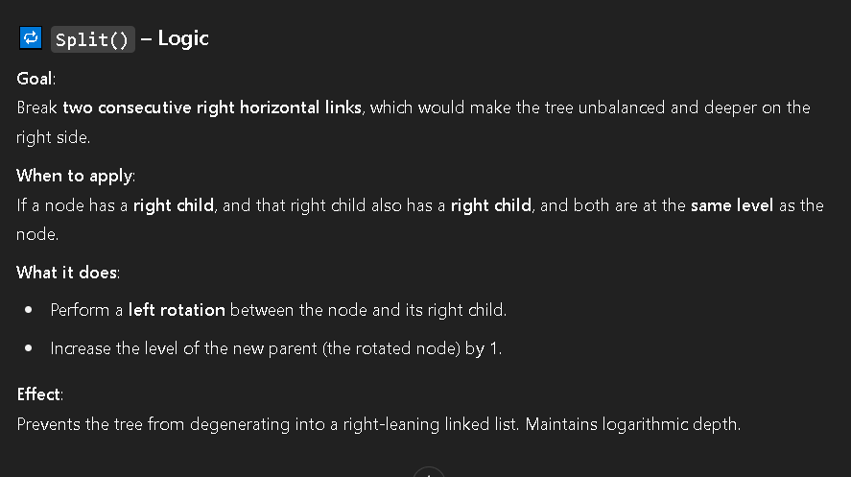

1. **Explain following terms w.r.t. symbol table : i) Insert & lookup operations ii) Advantages iii) Disadvantages**

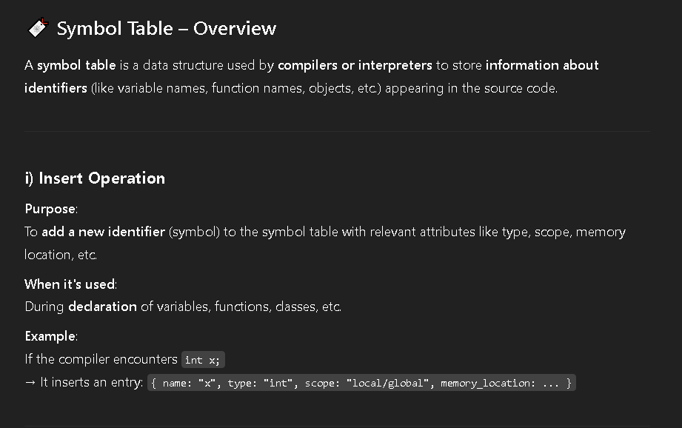

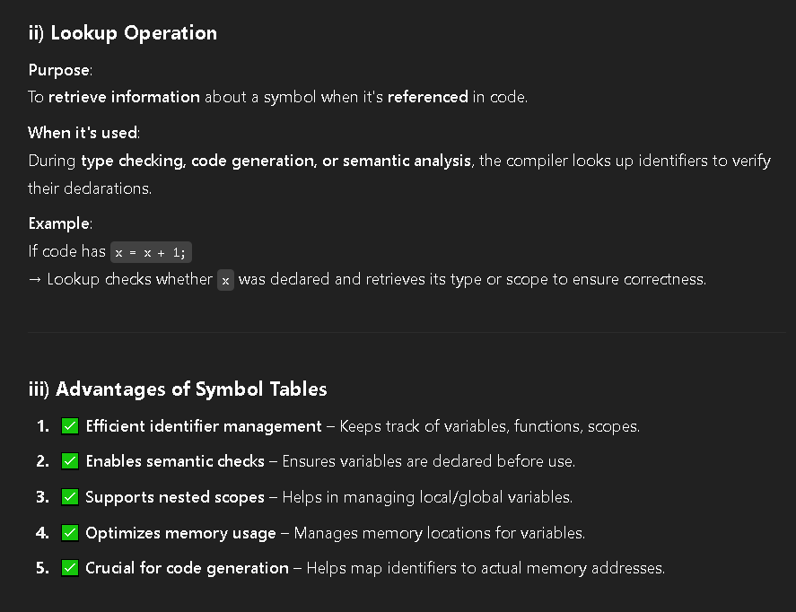

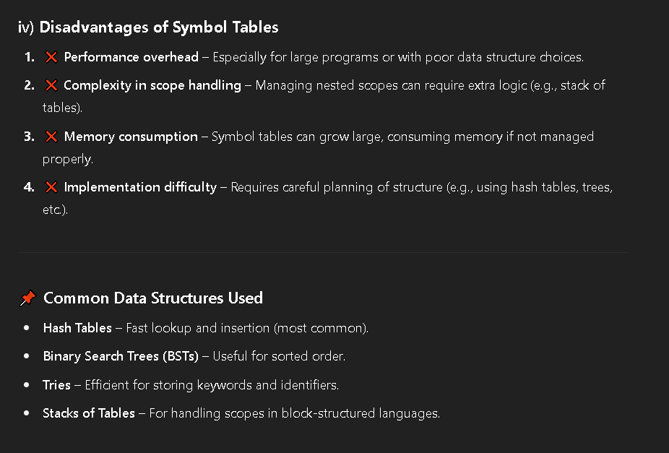

1. **Construct an AVL tree having the following elements : H, I, J, B, A, E, C, F, D, G**
2. **Insert 15, 10, 17, 7 in splay tree.**

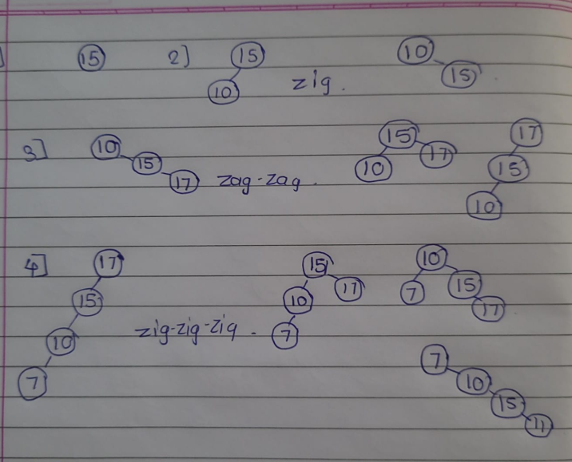

1. **What is the need of AA tree? List the five invariants that AA tree must satisfy.**

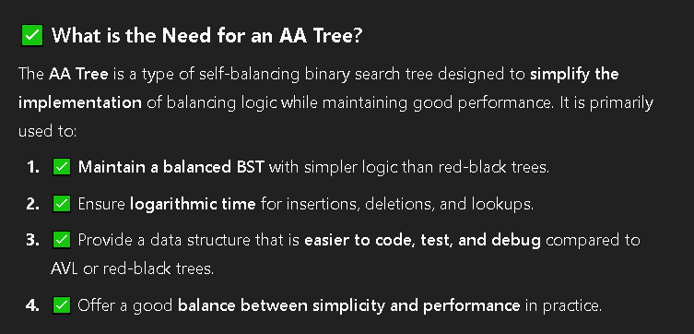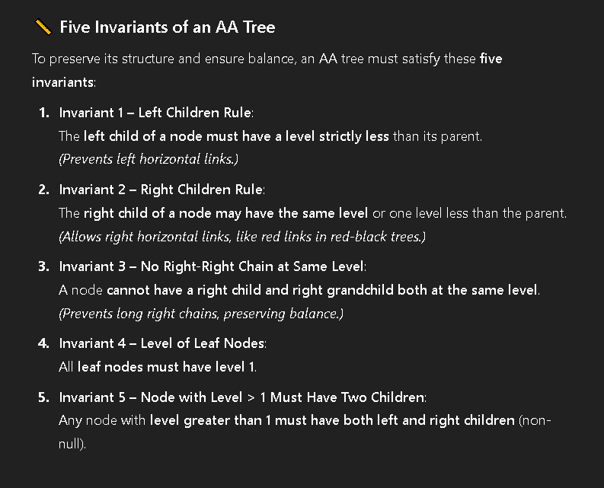

1. **Who developed K-D tree? What is the purpose of K-O tree? Insert step by step (7, 8), (12, 3), (14, 1), (4, 12), (9, 1), (2, 7) and (10, 19) into K-D tree.**

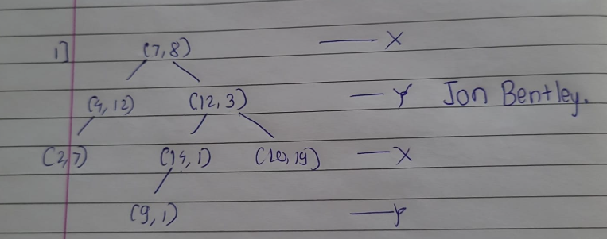

1. **Show the balanced AVL tree after deletion of mentioned node : i) Delete 30 ii) Delete 55 iii) Delete 60**

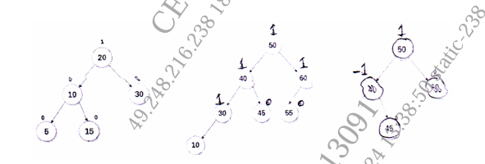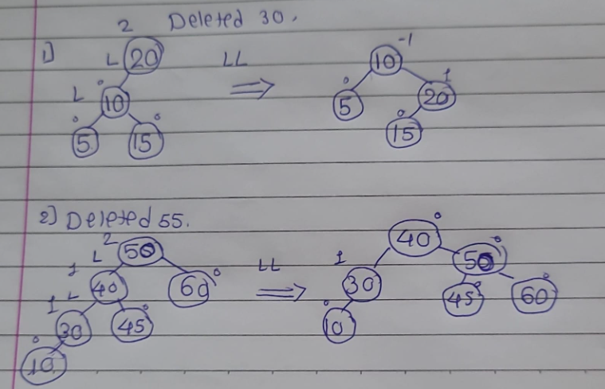

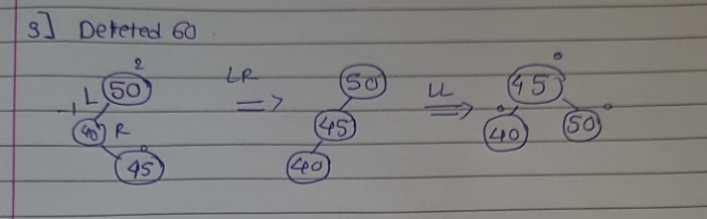

DSA

UNIT 5

1. **Construct a B-Tree of order 3 by inserting numbers from 1 to 10.**

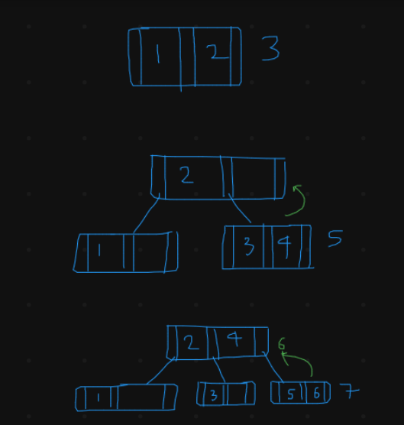

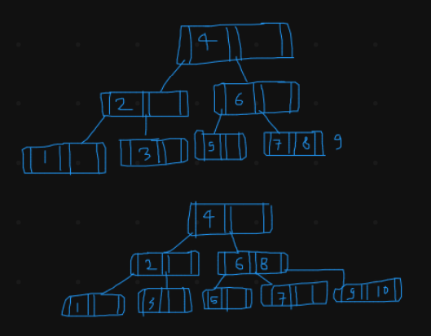

1. **Explain following primary index, Secondary index, Sparse index and Dense index with example.**

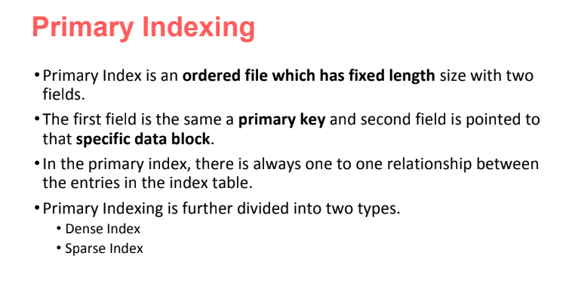

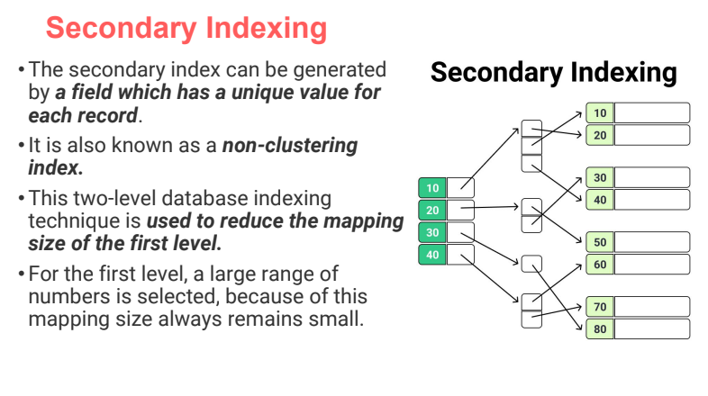

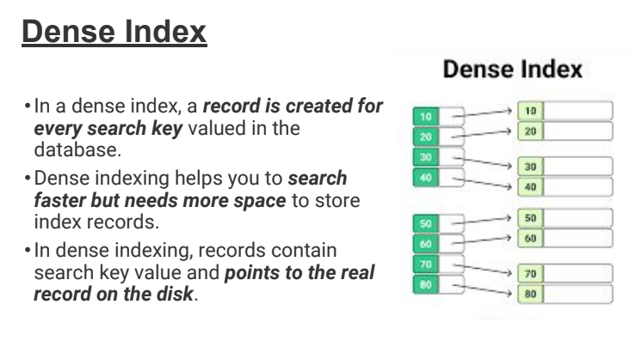

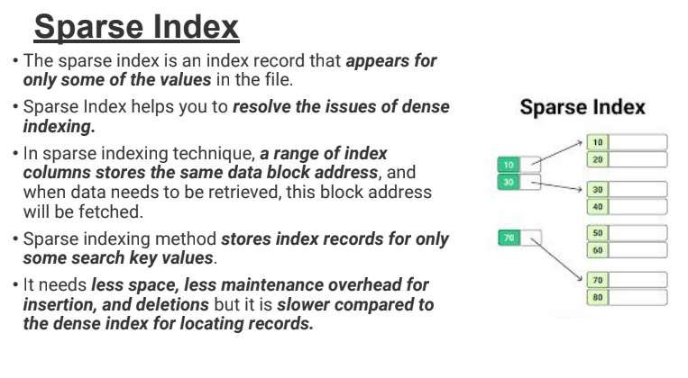

1. **Construct a B Tree of order 5 with the following data : D H Z K B P Q E A S W T C L N Y M**

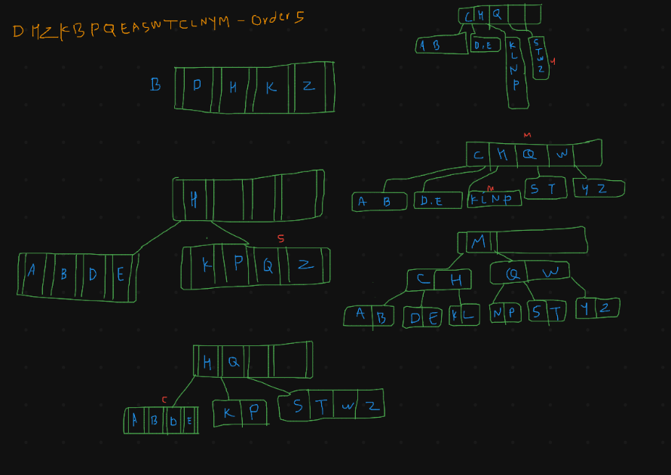

1. **What is trie tree? Explain insert and search operation on it.**

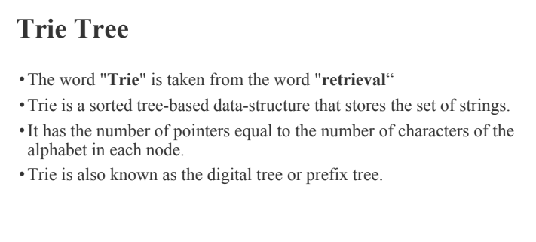

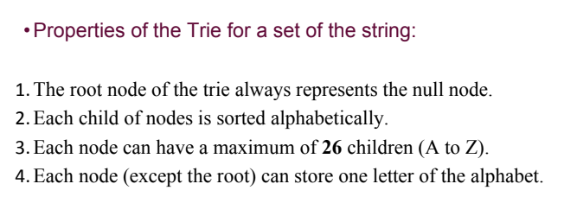

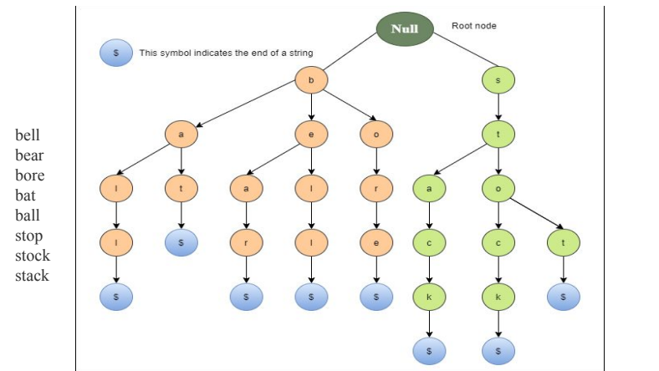

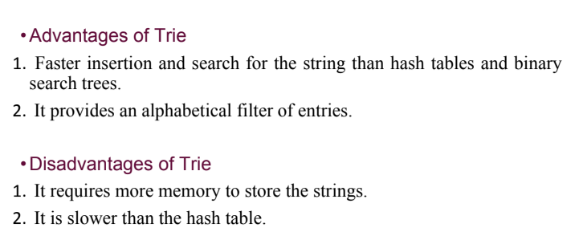

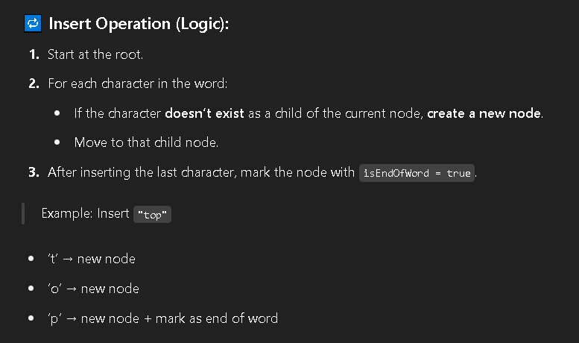

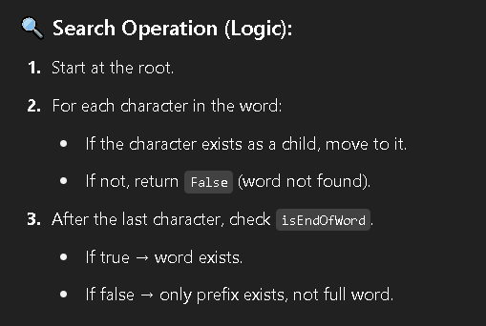

1. **Create a B- Tree of order 5 from the following list of data items: 30, 20, 35, 95, 15, 60, 55, 25, 5, 65, 70, 10, 40, 50, 80, 45**

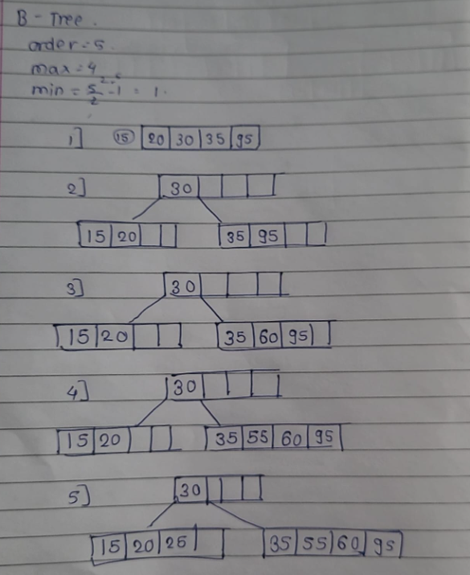

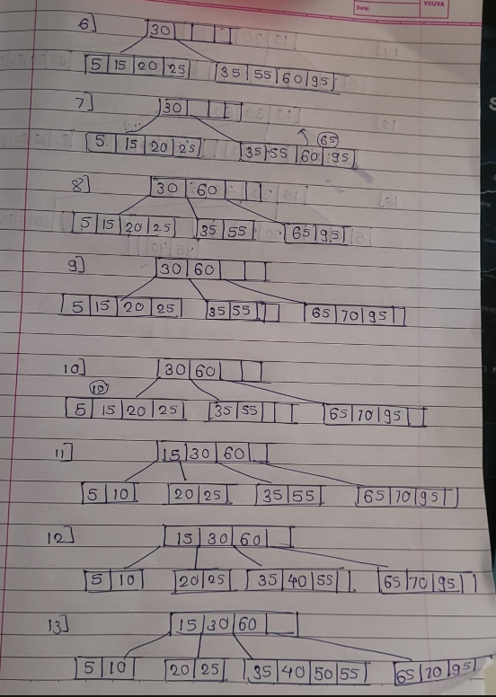

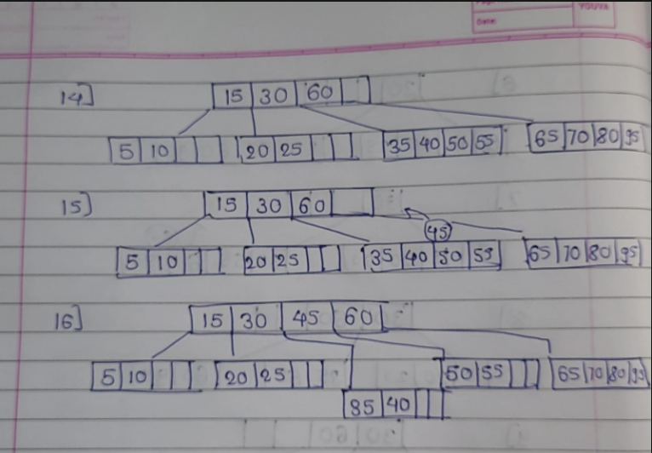

1. **Create a B+Tree of order 3 from the following list of data items: 1, 3, 5, 7, 9, 2, 4, 6, 8, 10**

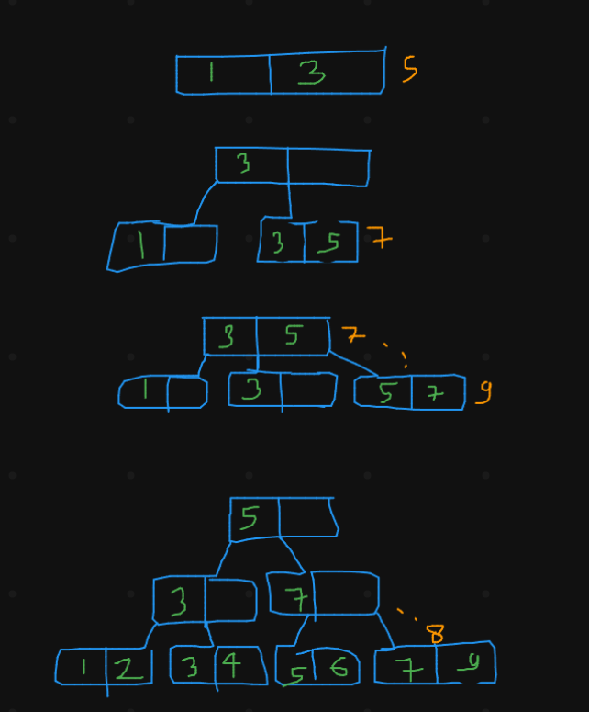

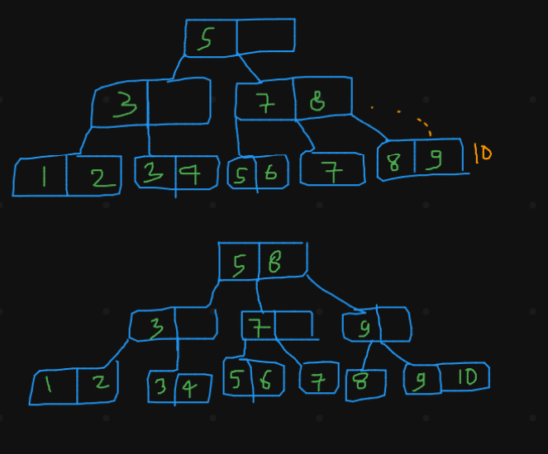

1. **Define trie tree. Compare trie tree with hash table. Draw trie tree for following data: bear, sell, bell, bid, stock, bull, buy, stop.**

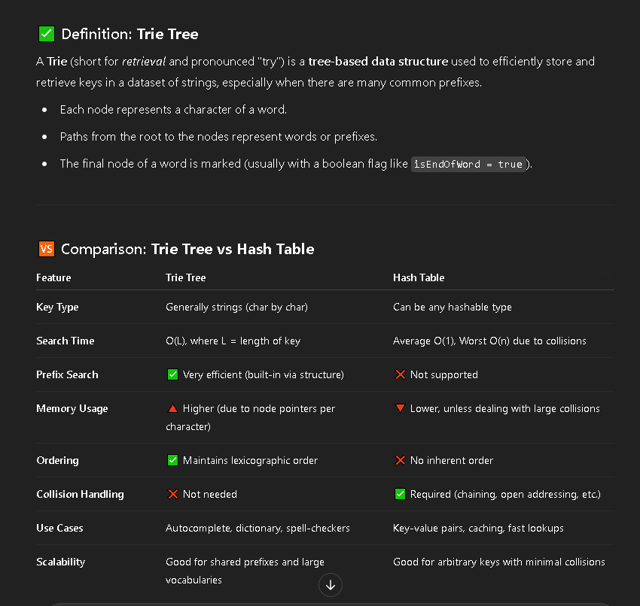

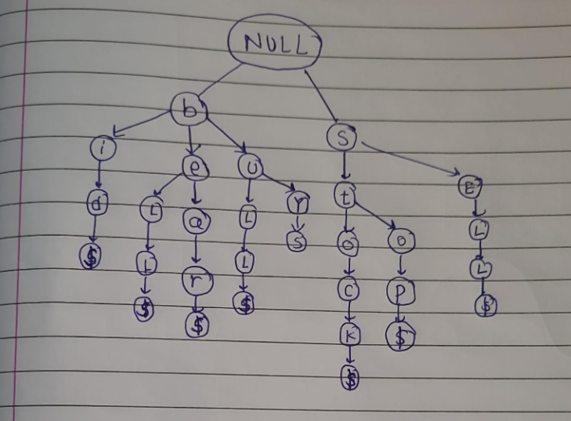

1. **What is indexing? What are the advantages of indexing? Discuss clustering index with example.**

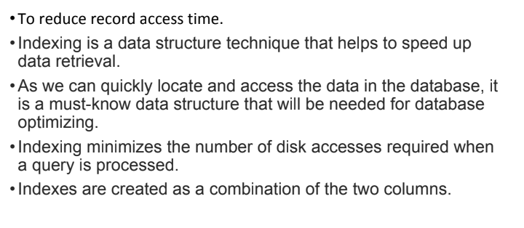

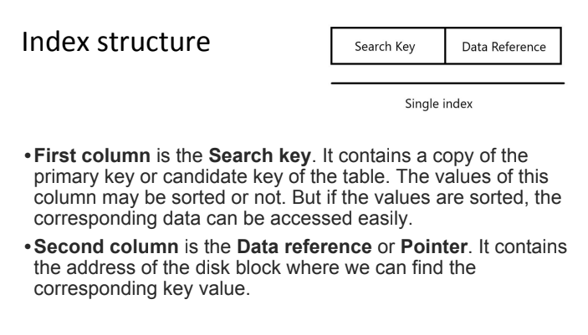

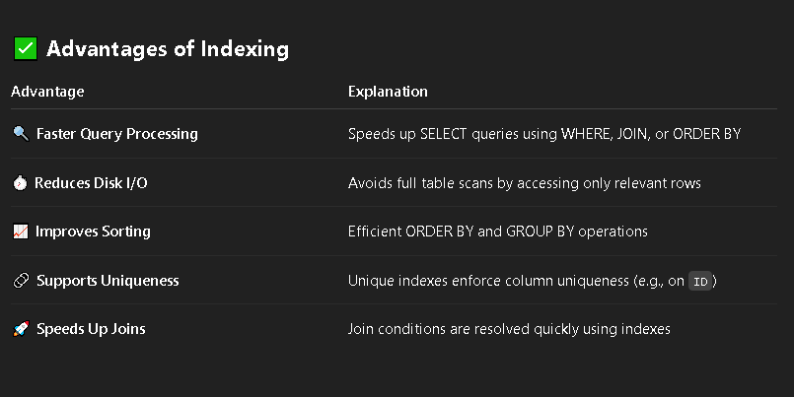

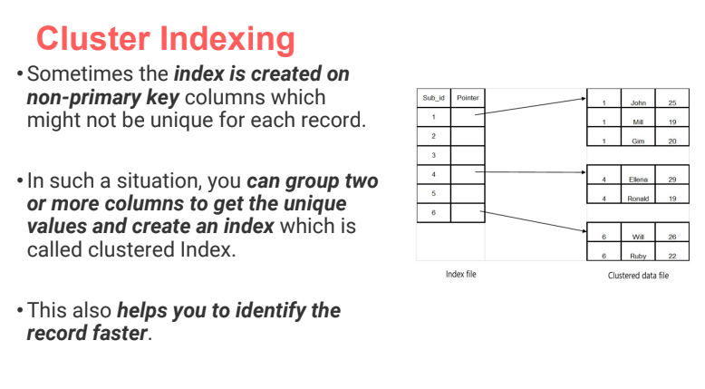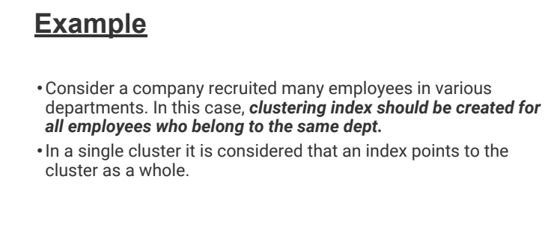

1. **Construct a B-Tree of order 3 for following data : 50, 30, 21, 90, 10, 13, 20, 70, 25, 92, 80.**

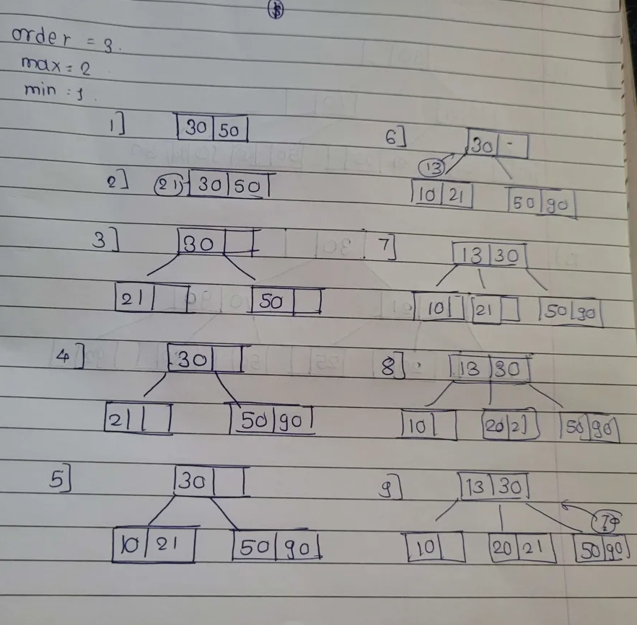

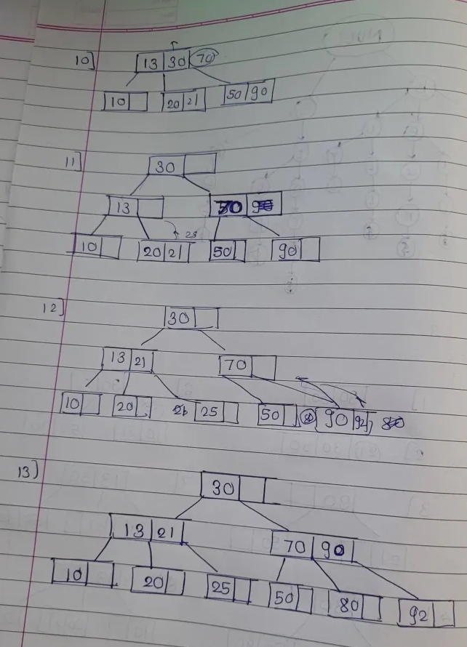

1. **Why B+ tree? List its properties and advantages.**

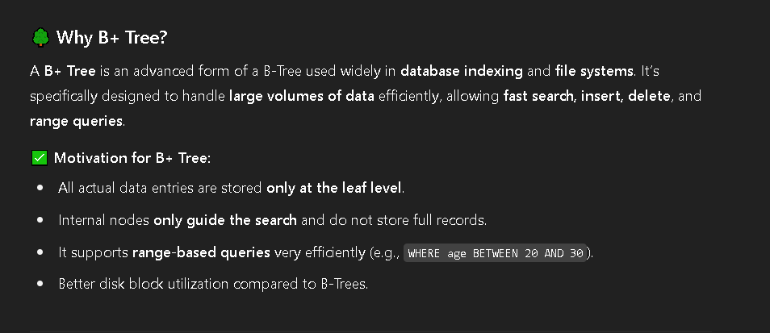

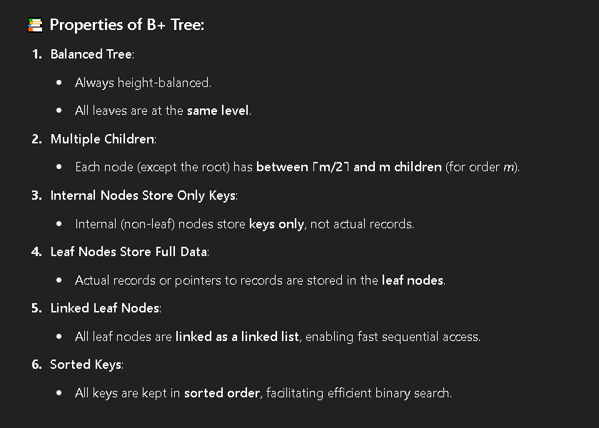

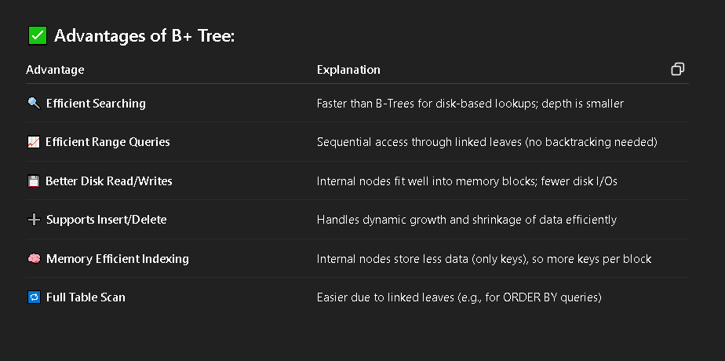

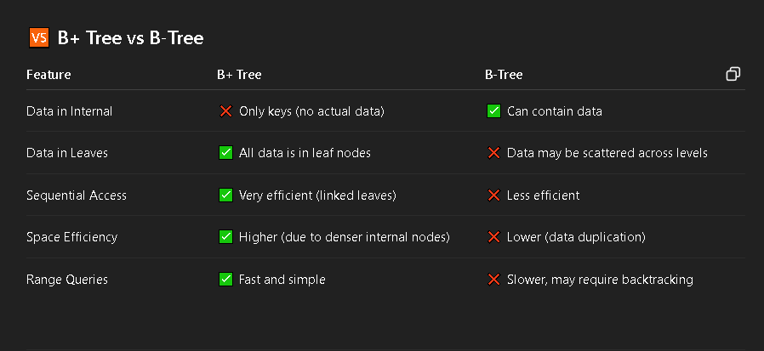

1. **Build B+ tree of order 3 for the following : F, S, Q, K, C, L, H, T, V, W, M, R**

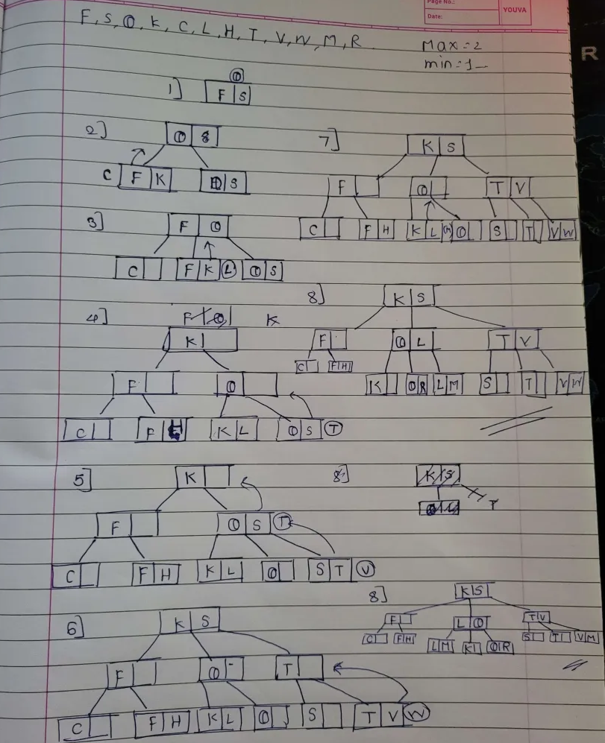

DSA

UNIT 5

1. **Explain multilist files & coral rings.**

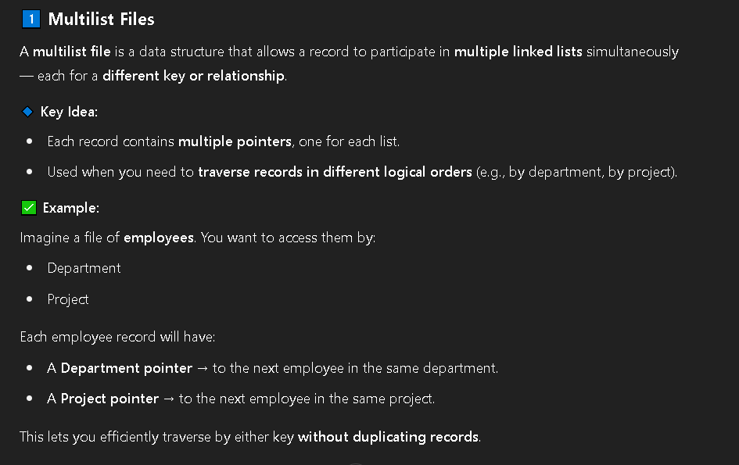

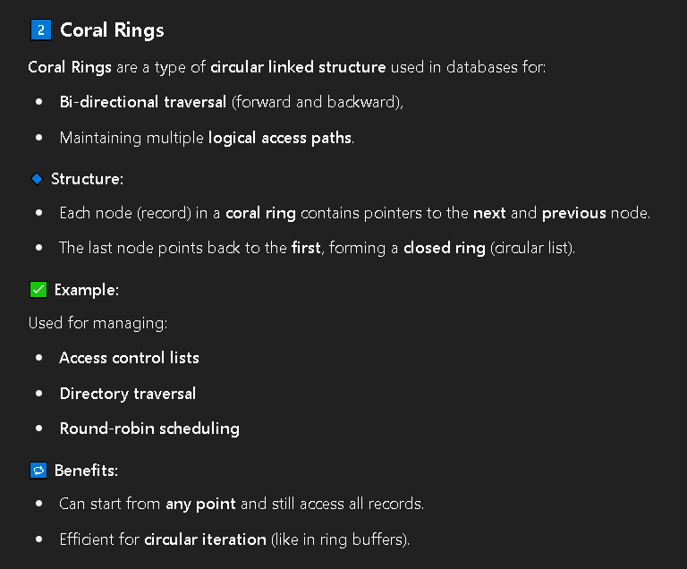

1. **What is Sequential and index sequential file organization? State its advantages and disadvantages**

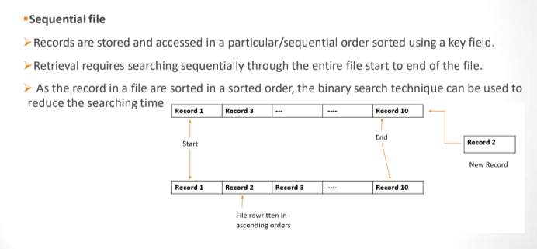

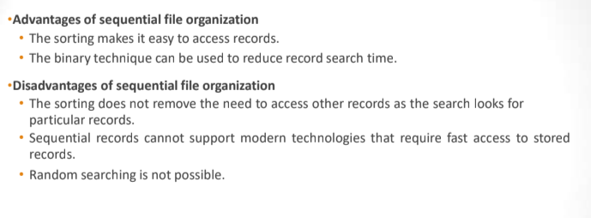

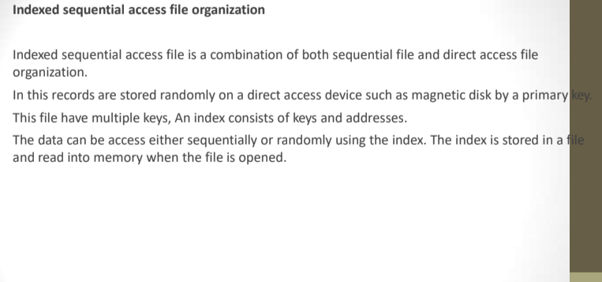

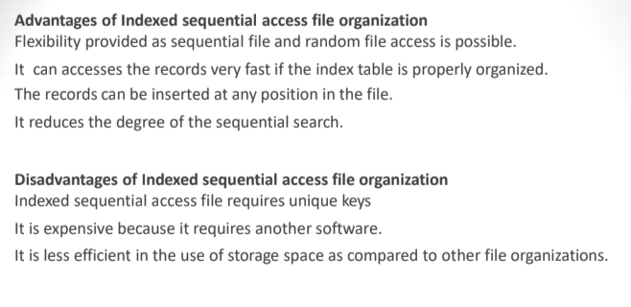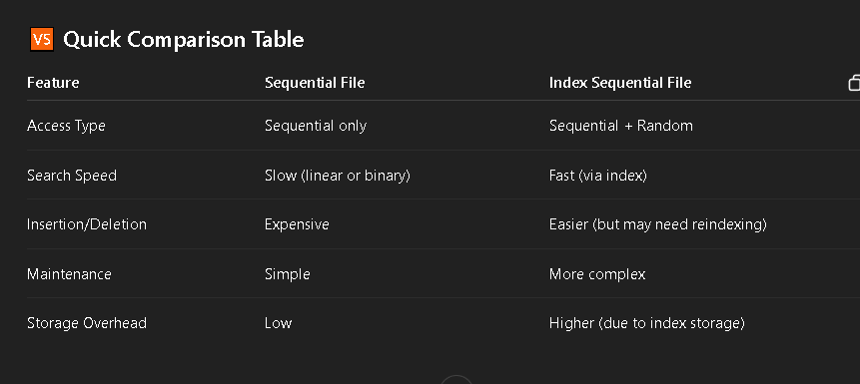

1. **Explain inverted file & cellular partitions.**

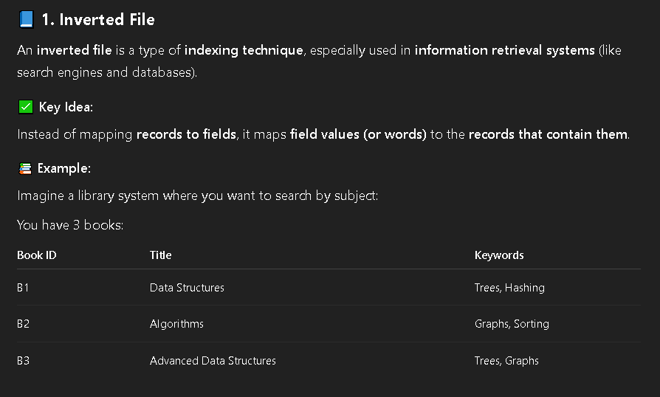

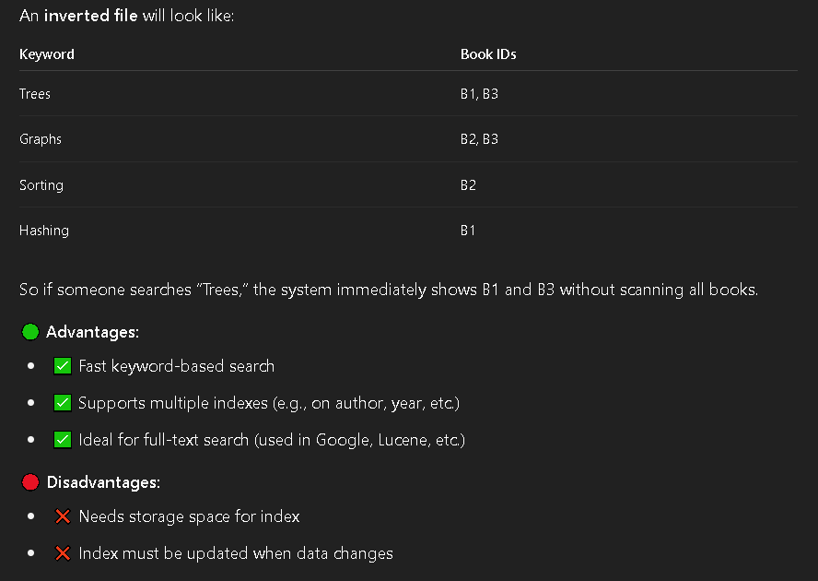

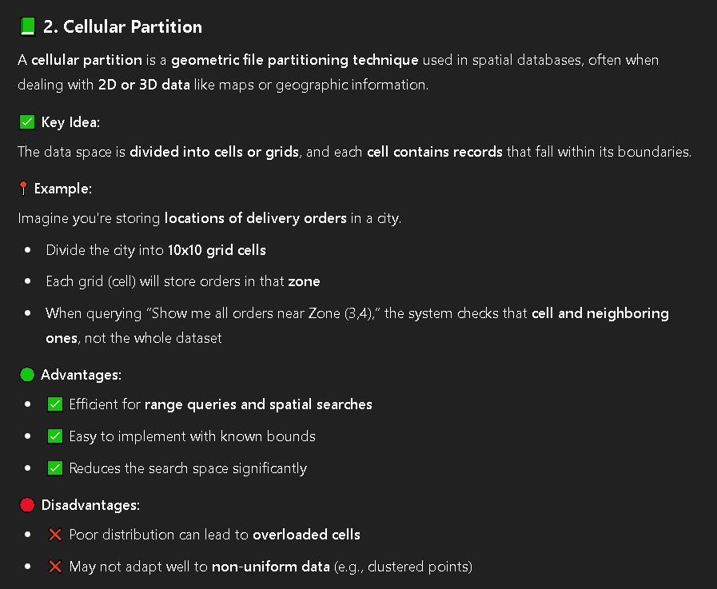

1. **Explain direct access file organization. State its advantages and disadvantages**

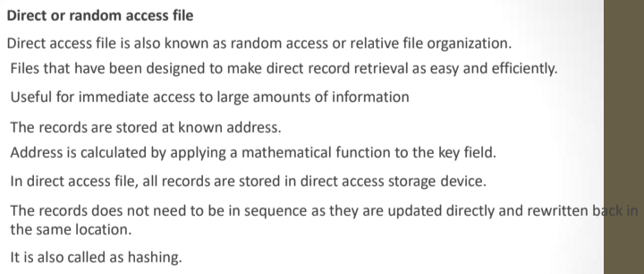

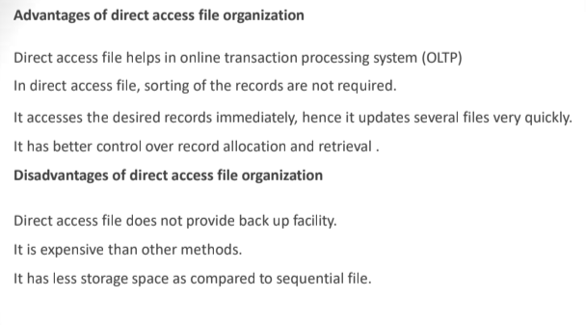

1. **What is linked organization? Explain inverted file and coral rings with respect to linked organization.**

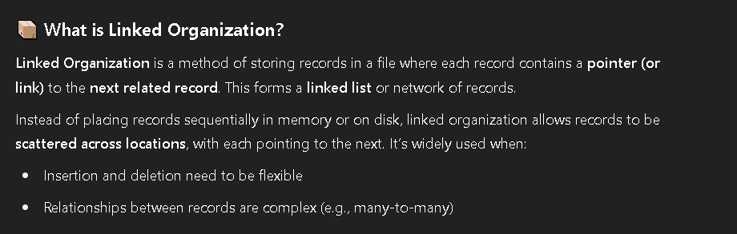

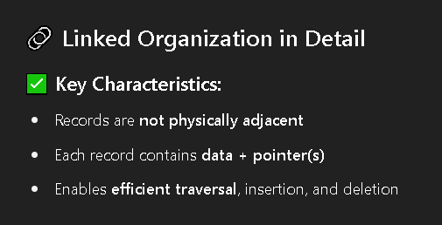

1. **List & explain two possible ways of representing records**
2. **Differentiate between indexed sequential file and direct access file.**

